AWS LAUNCHING INSTANCE IN EC2
In this we will learn how to launch an instance in EC2 (amazon elastic compute cloud)
STEP 1-
After signing in to your AWS go to EC2 service. From the EC2 dashboard select on the ‘Launch instance’ option.
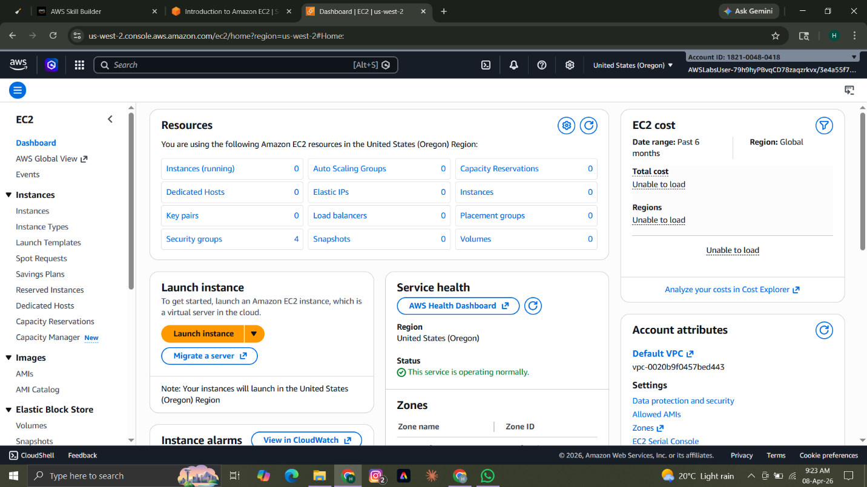
STEP 2-
Now give your instance a name and then select an AMI (Amazon machine image) which you want.
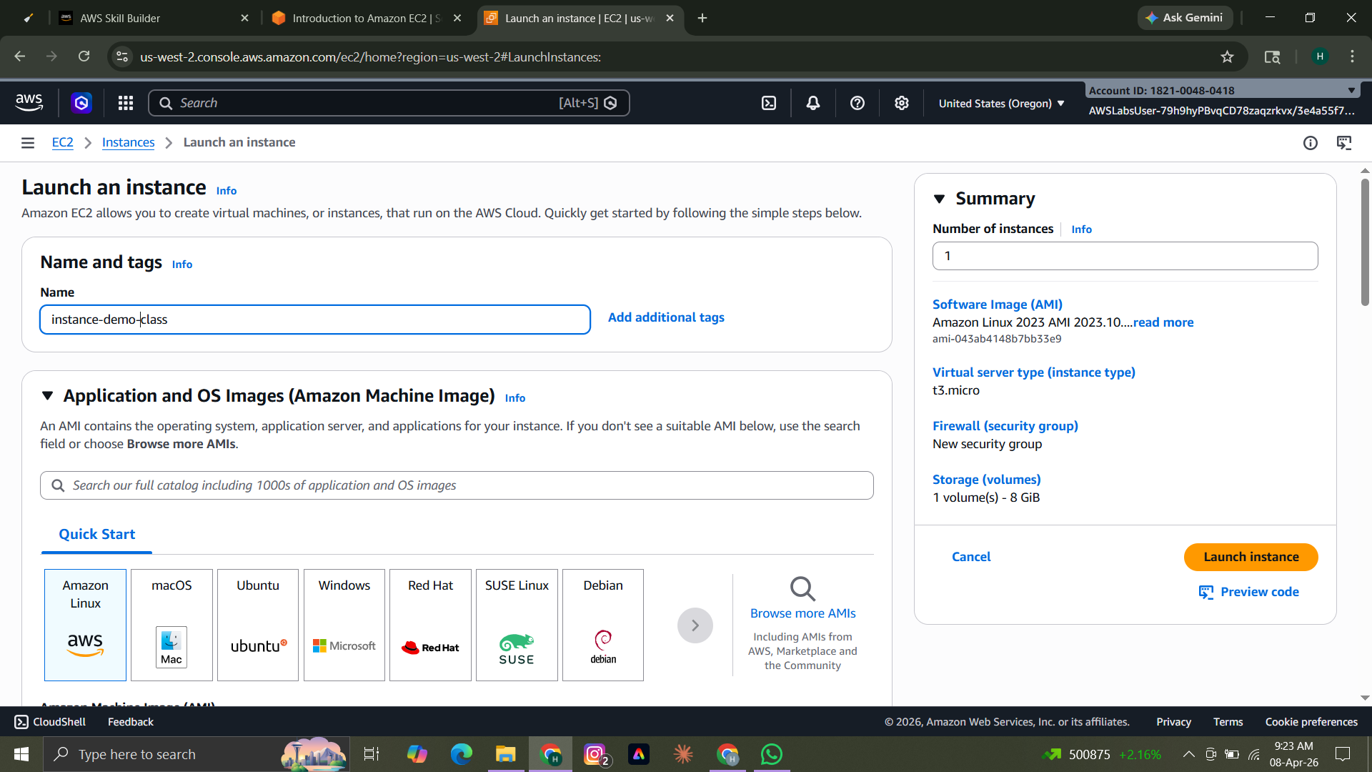
STEP 3-

Then choose the architecture which you want for your AMI.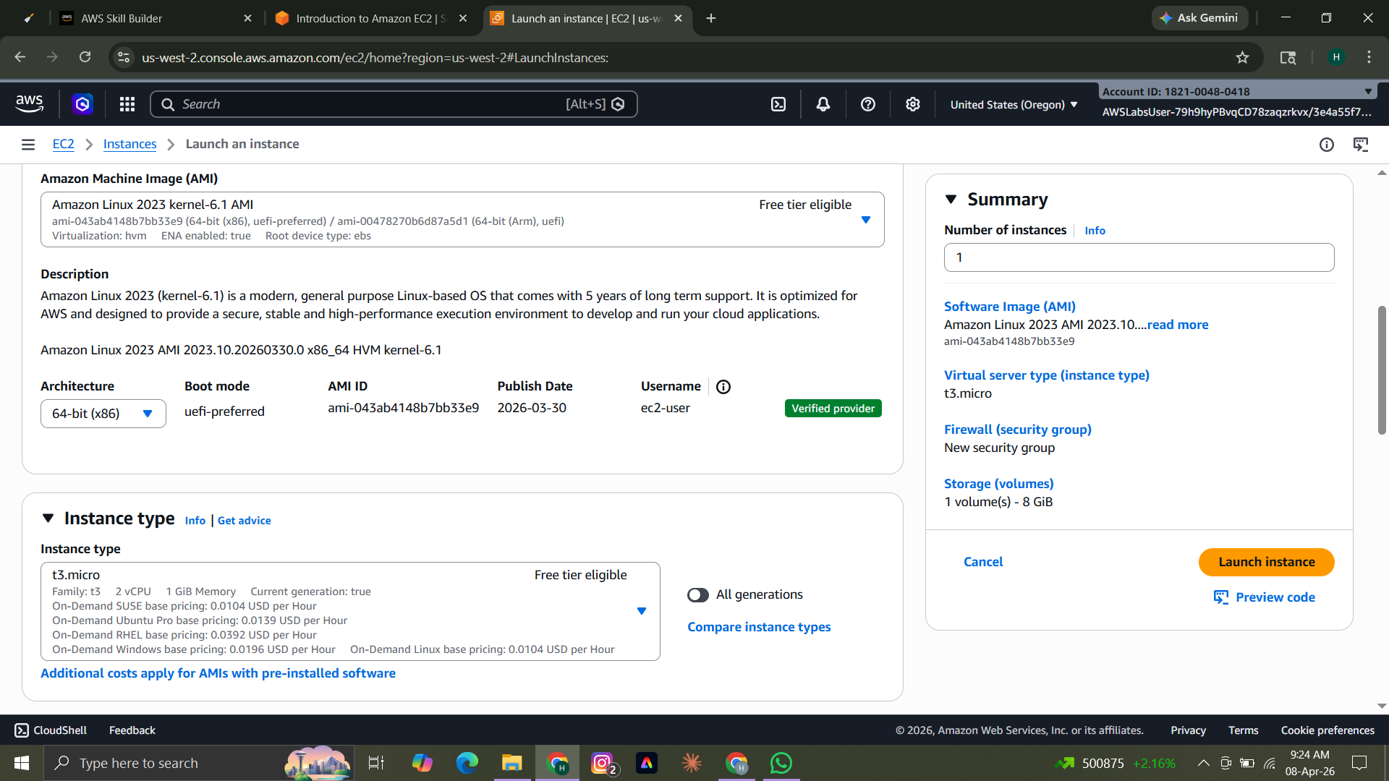
STEP 4-
Then select the instance type you want or you can leave as it is as default.There might be an additional cost for few of the options.
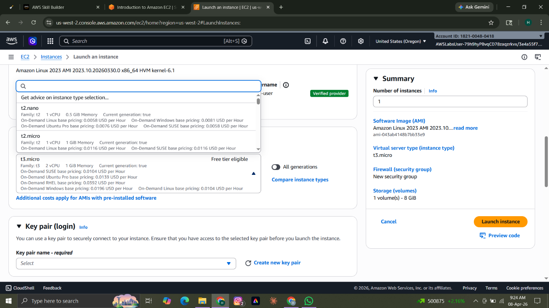
STEP 5(A)-
Key pair is like security for your instance. For every time you log in into you EC2 instance you would need your key pair and IP. It is totally optional for you to keep a key pair but it is recommended that you use a key pair for security.

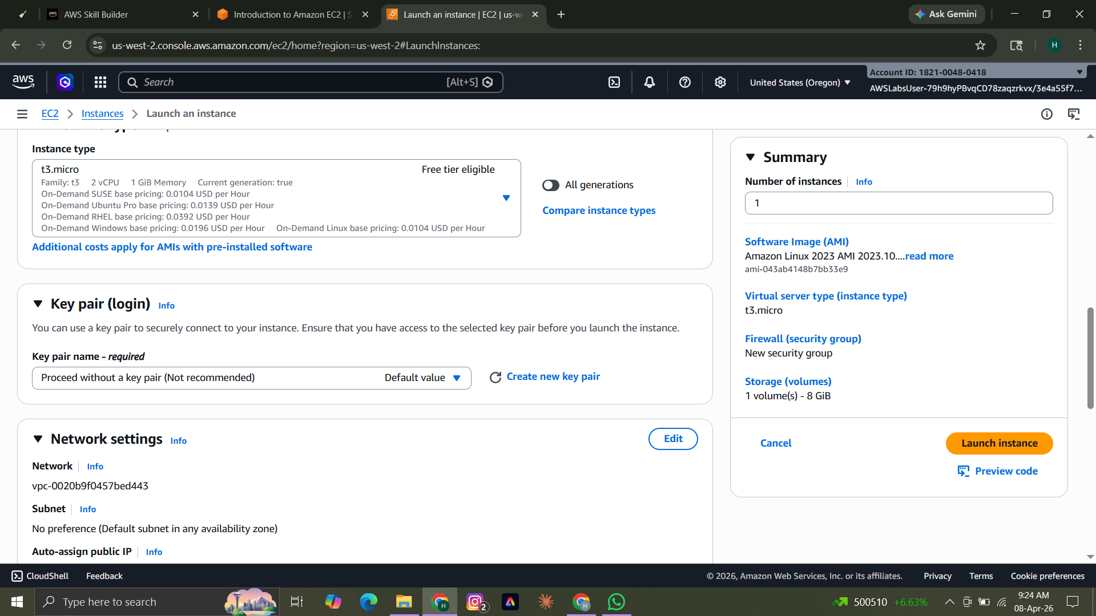
STEP 5(B)-
If you create a key pair the following screen. Give your key pair a name select the type and they for key format .pem is suitable for MAC and .ppk is suitable for Windows
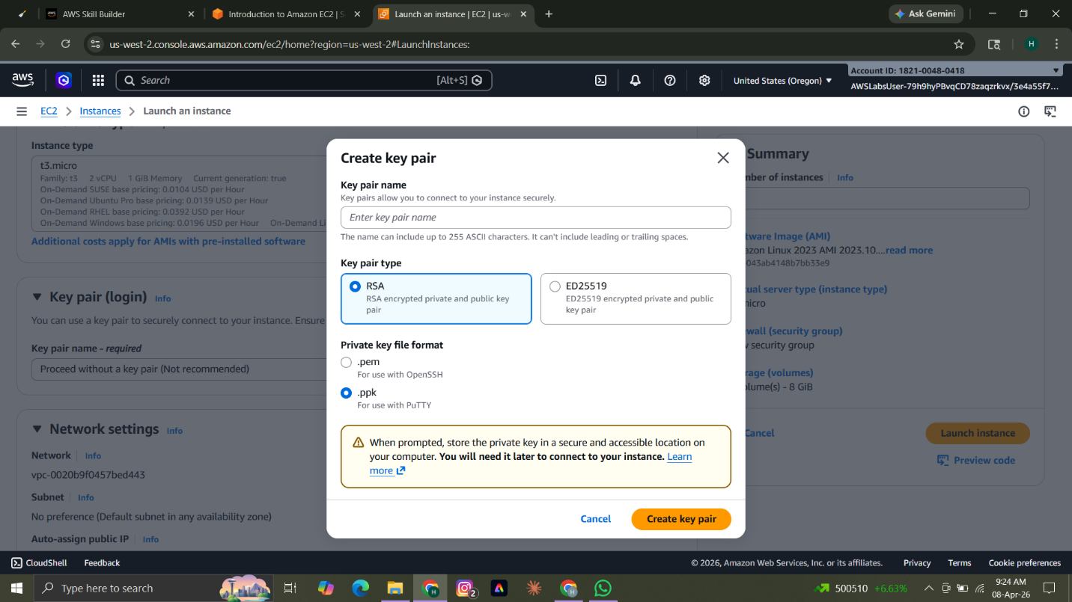
STEP 6-
In network settings check on all the three boxes shown.
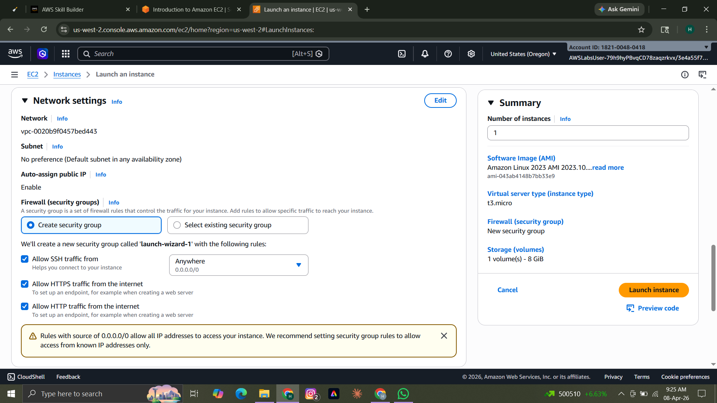
STEP 7-
Choose the configure store. Minimum and Maximum storage depends on the EBS volume type. You can also add another new volume in the configure storage.
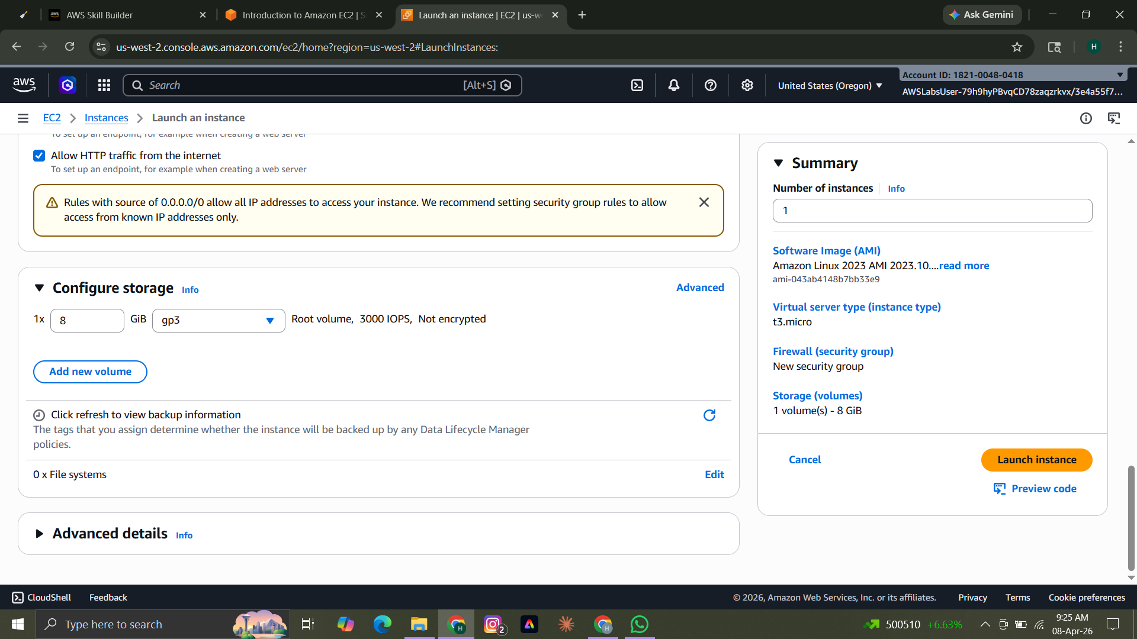
STEP 8-
After all of this click on ‘Launch Instance’ and your instance would be launched.

